GRADE | 10 | SUBJECT |  | CAT |  | WEEK |  | W5  L9 |  | TOPIC | Solution Development: Word Processing Tables: Split, AutoFit, Gridlines
LESSON SUMMARY FOR:
DATE STARTED |  |  |  |  |  |  | DATE COMPLETED
LESSON OBJECTIVES |  |  | At the end of this lesson the learner must be able to:  - Know how to split a table  - Allow text to automatically fit into the size of the cell  - Show the Gridlines of a table
TEACHER ACTIVITIES |  |  |  |  |  |  |  |  | LEARNER ACTIVITIES |  |  |  | TIMING | RESOURCES NEEDED
1. Methodology  - Hands on classroom activity  - Power point presentation  - Text book  2. Introduction  Revise parts of a table  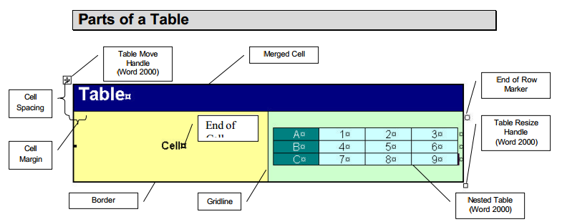  Borders and gridlines. By default, tables have a black ½-pt, single-line, solid-line border. If you remove this border, you will still see the gridlines that form the cell boundaries in light gray. Gridlines are not printed. If you would like to turn on or off  these gridlines, go to Table Show/Hide Gridlines.  End marks. End-of-cell and end-of-row marks are nonprinting characters that, like gridlines, appear only on the screen.  Cell spacing and margins. If you are using a table to arrange text or graphics, you can add spacing between table cells. You can also add cell “padding” (spacing between the boundary of the cell and the text inside the cell) by changing the cell margin.  Nested tables. If you use a table to layout a page, and you want to use another table to present information, you can insert a nested table - a table within a table.  Table move handle and resize handle. Use the table move handle to move the table to another place on a page, and use the table resize handle to change the size of a table.  3. Main Body (Lesson presentation)  Split a table :  Source:  http://compnetworking.about.com/cs/wireless/f/wirelesshardwar.htm  4. Conclusion |  |  |  |  |  |  |  |  | Folder DataFiles_Solutions for learners to practice  Computers  Part of your Life  p.  Via Afrika  p.  Focus  p. |  |  |  | Introduction and definition 10 minutes  The rest of the time allocated on explanation of the lesson | PowerPoint presentation  Data projector  Prescribed Textbooks  Computers  Part of your Life  p.  Via Afrika  p.  Focus  p.

Name of Teacher: HOD:
Sign: Sign:
Date: Date:

